Copulas: USDJPY and USDCAD
Method 18 / daily log returns / empirical ranks / Gaussian + Clayton / Alpari D1 full available history

Study setup
Logical pair: USDJPY , USDCAD
Broker symbols: USDJPY_i , USDCAD_i
Snapshot: 2026-11-03_majors_alpari_D1
Timeframe: D1
Matched return window: 1999-01-05 to 2026-11-02 (UTC bar dates)
Matched return count n: 7186
Dropped unfinished last bar dated 2026-11-03 UTC after a tick-volume check against the prior complete day.
Margins: empirical ranks / (n+1)
Families: Gaussian (rho) and Clayton (theta), fixed before ranking
Complete matched rows (Excel): USDJPY-USDCAD_Copula_D1.xlsx
Complete matched rows (HTML table): USDJPY-USDCAD_Copula_D1_data.html

Method carried forward
Copulas separate marginal return shapes from dependence on the unit square. Matched daily log returns of close, ln(close_t / close_t-1), are mapped to pseudo-observations u_i = rank(x_i)/(n+1) and v_i = rank(y_i)/(n+1). A Gaussian copula parameter rho is the Pearson correlation of Phi^{-1}(u) and Phi^{-1}(v). A Clayton copula theta >= 0 is fit by maximum likelihood on (u,v) for lower-tail asymmetry. Quotes are not inverted. Kendall tau implied by each fit and Spearman of (u,v) are stored. Same-sample Pearson r on returns is a side check. This is not causation and not a trading signal.

Results
Gaussian rho: 0.073263
Gaussian Kendall tau: 0.046682
Clayton theta: 0.101128
Clayton Kendall tau: 0.048130
Spearman of (u,v): 0.100814
Pearson r on returns: 0.027603

Conclusion
Over 7186 matched daily rows for USDJPY and USDCAD, Gaussian copula rho = 0.0733 (Kendall=0.0467) and Clayton theta = 0.1011 (Kendall=0.0481). Spearman of (u,v) = 0.1008; Pearson r on returns = 0.0276. This is not causation and not a trading signal.

Charts
Daily closes

Daily log returns

Pseudo-observations (u,v)
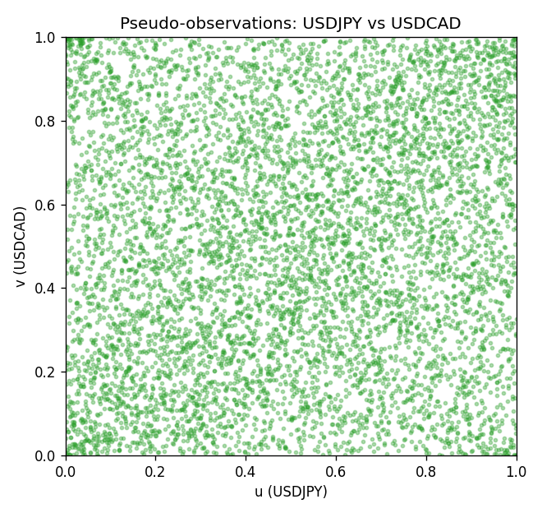

Data report
Every matched row is stored in the sibling Excel workbook named USDJPY-USDCAD_Copula_D1.xlsx, including u and v. Embedding all rows as a Word table is impractical; this file holds column summaries and the first and last 15 matched rows.
Columns: time, USDJPY_open, USDCAD_open, USDJPY_high, USDCAD_high, USDJPY_low, USDCAD_low, USDJPY_close, USDCAD_close, USDJPY_tick_volume, USDCAD_tick_volume, USDJPY_spread, USDCAD_spread, USDJPY_real_volume, USDCAD_real_volume, USDJPY_log_return, USDCAD_log_return, u, v
Column summaries (matched calculation rows)
column | count | mean | std | min | 25% | 50% | 75% | max
USDJPY_open | 7186 | 113.80748 | 19.222412 | 75.693 | 104.39025 | 110.981 | 120.70625 | 163.824
USDCAD_open | 7186 | 1.266789 | 0.16892251 | 0.9168 | 1.118445 | 1.2985 | 1.37213 | 1.6183
USDJPY_high | 7186 | 114.30511 | 19.284087 | 76.001 | 104.8685 | 111.4395 | 121.2675 | 163.978
USDCAD_high | 7186 | 1.2716872 | 0.16888037 | 0.9336 | 1.122975 | 1.303895 | 1.37655 | 1.619
USDJPY_low | 7186 | 113.28446 | 19.150257 | 75.402 | 103.88 | 110.53 | 120.1715 | 163.628
USDCAD_low | 7186 | 1.2622311 | 0.16895752 | 0.9056 | 1.114125 | 1.293555 | 1.367815 | 1.6102
USDJPY_close | 7186 | 113.82065 | 19.237762 | 75.811 | 104.38275 | 111.018 | 120.69375 | 163.851
USDCAD_close | 7186 | 1.2668036 | 0.16889539 | 0.916 | 1.118165 | 1.29848 | 1.372395 | 1.6137
USDJPY_tick_volume | 7186 | 106329.64 | 179429.89 | 149 | 9948.5 | 53187 | 92874.5 | 1803508
USDCAD_tick_volume | 7186 | 81037.769 | 147318.12 | 37 | 5546.5 | 40944 | 71631 | 1410818
USDJPY_spread | 7186 | 20.270804 | 17.617829 | 0 | 6 | 11 | 30 | 50
USDCAD_spread | 7186 | 23.436682 | 18.263202 | 0 | 9 | 17 | 40 | 60
USDJPY_real_volume | 7186 | 3.4776211e+10 | 1.6092546e+11 | 0 | 0 | 0 | 0 | 3.8834203e+12
USDCAD_real_volume | 7186 | 1.8381818e+10 | 9.6701063e+10 | 0 | 0 | 0 | 0 | 2.5751613e+12
USDJPY_log_return | 7186 | 5.053e-05 | 0.00620694 | -0.03908203 | -0.00319936 | 0.00011986 | 0.0034094 | 0.05184024
USDCAD_log_return | 7186 | -1.555e-05 | 0.00514357 | -0.03859748 | -0.00283709 | 4.741e-05 | 0.00272359 | 0.03436319
u | 7186 | 0.5 | 0.28865504 | 0.00013914 | 0.25006957 | 0.5 | 0.74993043 | 0.99986086
v | 7186 | 0.5 | 0.28865505 | 0.00013914 | 0.25006957 | 0.5 | 0.74993043 | 0.99986086
First 15 matched rows (selected columns)
time | USDJPY_log_return | USDCAD_log_return | u | v
1999-01-05 | -0.00017868311 | -0.010131666 | 0.47112843 | 0.026854042
1999-01-06 | 0.0075660159 | -0.0003306769 | 0.91150689 | 0.46458884
1999-01-07 | -0.012851583 | 0.0015202092 | 0.023236399 | 0.65214971
1999-01-08 | -0.0047719894 | -0.0020495197 | 0.16849868 | 0.30457771
1999-01-11 | -0.016195423 | -0.0035137769 | 0.013357451 | 0.20801447
1999-01-12 | 0.032310364 | 0.0066194721 | 0.99958258 | 0.9247252
1999-01-13 | 0.0081373171 | 0.0045420214 | 0.92486434 | 0.85557256
1999-01-14 | 0 | 0.0069376546 | 0.48733825 | 0.93182134
1999-01-15 | 0.0055343401 | -0.0056905671 | 0.8515375 | 0.10755531
1999-01-18 | 8.7600193e-05 | 0.00098344542 | 0.49714763 | 0.59774593
1999-01-19 | -0.0056219403 | 0.002748513 | 0.13955753 | 0.75191318
1999-01-20 | -0.0053879917 | -0.0059646885 | 0.14651454 | 0.099067761
1999-01-21 | 0.0084664056 | -0.0042823796 | 0.92945596 | 0.16223737
1999-01-22 | 0.0060412564 | 0.0025057712 | 0.86920829 | 0.73410324
1999-01-25 | -0.0073594164 | 0.00085579808 | 0.092249896 | 0.58577988
Last 15 matched rows (selected columns)
time | USDJPY_log_return | USDCAD_log_return | u | v
2026-10-13 | -0.0018932826 | -0.0046395653 | 0.32795325 | 0.14943648
2026-10-14 | 7.5800166e-05 | 0.0015184751 | 0.49547795 | 0.65201057
2026-10-15 | -0.0018524319 | -0.0036101503 | 0.33087519 | 0.20217059
2026-10-16 | -0.00037976126 | -0.0034322068 | 0.45011827 | 0.21358008
2026-10-19 | 0.0034946841 | -0.0018835331 | 0.75455684 | 0.31904828
2026-10-20 | -0.0022546642 | -0.0037066008 | 0.30402115 | 0.19521358
2026-10-21 | -0.00032883504 | -0.00084691787 | 0.45610129 | 0.41435926
2026-10-22 | -0.0085942669 | -0.0026307268 | 0.066648115 | 0.26547934
2026-10-23 | 0.00035080446 | 2.85545e-05 | 0.52163629 | 0.49909559
2026-10-26 | 0.0041238746 | 5.7106554e-05 | 0.79128983 | 0.50104355
2026-10-27 | 0.0027651658 | 0.0025379458 | 0.71156254 | 0.7374426
2026-10-28 | -0.00095679538 | -0.0038379274 | 0.39821901 | 0.18561291
2026-10-29 | -0.00038043789 | -0.00011436495 | 0.44997913 | 0.48476416
2026-10-30 | -0.0010596481 | -0.0010298736 | 0.39167942 | 0.39585362
2026-11-02 | 0.0026438521 | 0.00061519094 | 0.70335328 | 0.56101294

